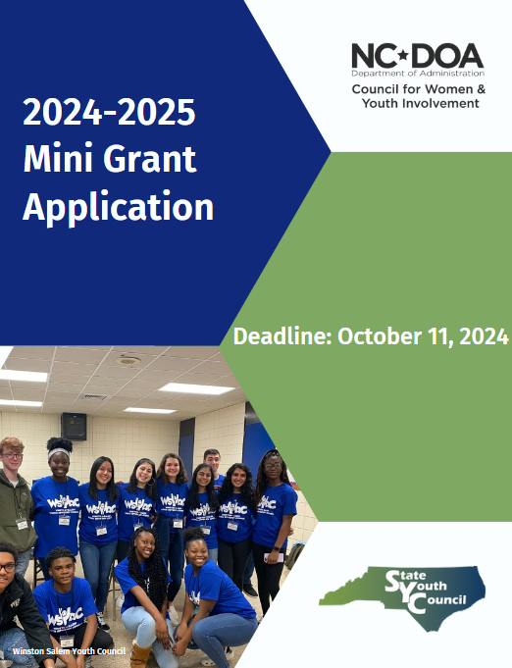

Department of Administration – North Carolina Council for Women & Youth Involvement
North Carolina Youth Advisory Council – North Carolina State Youth Council
Mini-Grant Application FY 2024-2025
Eligibility Requirements
To qualify for a mini-grant, applicant organizations should:

- Be a youth program located in North Carolina and interested in developing innovative youth programs that are directed by youth.
- Be a local government agency or 501(c)(3) non-profit organization.
- Involve youth in project development, implementation, evaluation and writing of grant proposals.
- We invite applications for projects related to youth programs supporting their groups and communities.
- The project funded by the grant should be youth supporting their local community.
Application Requirements
The application is fill-in. Complete the application, print, and sign.

- All initial funding requests must not be less than $100.00 and not more than $500.00.
- Grant applications must be received by email by 5:00pm on October 4, 2024.
- Non-profit organizations must submit a letter of reference with the application. This letter may come from a local government official or the sponsoring agency director and must be signed by that person. If the letter is not submitted with the application, the application will not be considered.
- Funds must be used to directly fund the project and cannot be used for the following expenses: clothing, salaries, scholarships, transportation, entertainment, awards, gifts, incentives, tickets, or food.
Grant Requirements
- Required progress reports must be submitted to the Council for Women & Youth Involvement Office.
- Project must be completed within 90 days of designated completion date as documented in the Program Description.
- Source of project funds must be stated in all documents, publications, media, and oral or visual presentations related to the project.
Disbursement of Grant Funds
- Mini-grants are intended as seed money, not as total program funding.
- Funds are normally dispersed several weeks after the approval of the contract in the sum of the grant awarded
- Consider when requesting a grant that you will receive your funds in Spring 2025.

Email Completed Application Packet to:
Doa.youth.involvement@doa.nc.gov
Deadline: Friday, October 11, 2024

2024-2025 Mini-Grant Disbursement Timeline
August 19, 2024 | Mini-Grant Application Opens
October 11, 2024 | Mini-Grant Application Closes
December 12, 2024 | Mini-Grants Approved by Youth Advisory Council
January 20, 2024 | Contract Submission Deadline
February 2024 | Distribution of Funds to Grantees

Name of Organization: Click or tap here to enter text.
General Information

Federal Tax ID Number (TIN): Click or tap here to enter text.

Physical Address of Organization (Do not use P.O. Box): Click or tap here to enter text.

County: Click or tap here to enter text.

Web Address: Click or tap here to enter text.

Contact Person (Adult) for Organization: Click or tap here to enter text.

Telephone Number of Contact Person: Click or tap here to enter text.

Email Address of Contact Person: Click or tap here to enter text.
The Organization
Are you a chartered State Youth Council? Click or tap here to enter text.
If yes, which council? Click or tap here to enter text.

Age of Organization: Click or tap here to enter text.

Number of Youth Members: Click or tap here to enter text.

Ending date of organization’s fiscal year: Click or tap here to enter text.

Is the organization funded? ☐ Yes ☐ No
(If yes, give a brief statement of amount and purpose of funding)
Click or tap here to enter text.

Give a brief history of the organization. Click or tap here to enter text.

Have you previously received a Mini-Grant from the Council for Women & Youth Involvement Office? ☐ Yes ☐ No
(If yes, when, and for what project? Briefly describe the results of the project.)
Click or tap here to enter text.

Is your organization seeking funds from other sources? ☐ Yes ☐ No
If yes, list sources and amounts.
Click or tap here to enter text.

Grant Amount Requested: Click or tap here to enter text.
The Project

Number of youth the project will serve: Click or tap here to enter text.

Age range of youth to be served: Click or tap here to enter text.

Will project continue after all mini-grant funds are exhausted? ☐ Yes ☐ No
(If yes, explain how it will continue)
Click or tap here to enter text.

Don’t Forget to:
Complete the itemized budget sheet included in this application.
Complete the project description sheet included in this application.

Signatures and Verification of Review of Grant Application
By placing our signatures below (e-signatures allowed), we hereby certify and confirm that this application provides accurate and true statement regarding the purpose and obligations of our agency. We further certify and confirm that we have read, reviewed, and understand all materials.

________________________________________________ ______________________________________
Organization Chairperson (Youth) Printed Name Age

_______________________________________________ ______________________________________
Organization Chairperson (Youth) Signature Date

________________________________________________
Organization Chairperson (Adult) Printed Name

_______________________________________________ __________________________________
Organization Chairperson (Adult) Signature Date

*Amount cannot be less than $100 and no more than $500*
Itemized Project Budget

Budget Items Cost
1 | Click or tap here to enter text.
2 | Click or tap here to enter text.
3 | Click or tap here to enter text.
4 | Click or tap here to enter text.
5 | Click or tap here to enter text.
6 | Click or tap here to enter text.
7 | Click or tap here to enter text.
8 | Click or tap here to enter text.
9 | Click or tap here to enter text.
10 | Click or tap here to enter text.
11 | Click or tap here to enter text.
12 | Click or tap here to enter text.
13 | Click or tap here to enter text.
14 | Click or tap here to enter text.
15 | Click or tap here to enter text.
 | Total | 0.00

Project Description

Give a detailed description of the project, stating purpose and goals. Also, give a project timetable, including specific dates. If more funding was available, how would your organization use it? (This question is optional and is not required to receive funding.)

Click or tap here to enter text.

