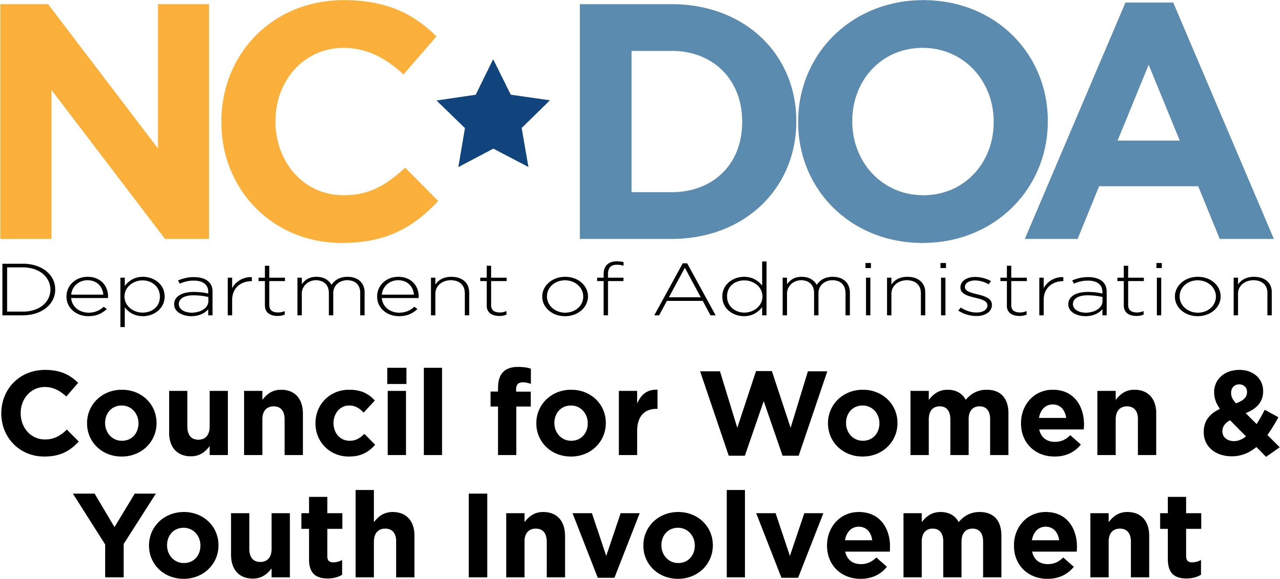

N. C. Department of Administration/Domestic Violence Commission
Domestic Violence Intervention Programs
Annual Renewal Process

The following document outlines the procedures and process for the annual review of each approved Domestic Violence Intervention Program (DVIP) by the Domestic Violence Commission as described in the North Carolina Administrative Code. 01 NCAC 17.0703 (a) provides that “In addition to initial approval, each [DVIP] shall be reviewed annually by the commission.” The rules, along with the renewal application, are available at https://ncadmin.nc.gov/advocacy/women/domestic-violence-intervention-program or by contacting the NC CFW&YI Western Region Office at 828-641-7730 or DVIP@doa.nc.gov.

INSTRUCTIONS:

- Complete the DVIP Annual Renewal document that begins on page 2.

- Provide the following documentation:
- An updated and signed Memorandum of Understanding (MOU) with the local Victim Service agency(ies) in each county where you are providing services in-person or virtually. (A TASC MOU does not fulfill this requirement).
- Certifications and/or any documentation (from January 2024 through January 2025) of continuing education in domestic violence training, for each DVIP staff. Direct Services Staff must have a minimum of 20 hours, and Group Facilitator(s) must have a minimum of 6 hours. This training may be obtained through a combination of internal (i.e., presented within the agency as an in-service, with documentation) and external sources (i.e., regional or state conferences, on-line presentations, with documentation).
- Any updated Intake and Client Contract Materials.

Renewal forms must be submitted to dvip@doa.nc.gov
by January 31, 2025.

(No Faxed or Mailed Copies Accepted)

Domestic Violence Intervention Program Annual Renewal

Date of Renewal: Click or tap to enter a date.

Number of years agency has been providing DVIP services: Click or tap here to enter text.

- Provider Identification (Administrative Location):

- Name of Agency: Click or tap here to enter text.

- Name of DVIP if different from Agency name: Click or tap here to enter text.

- Administrative Address: Click or tap here to enter text.

- Do you give approval to have this address and phone number made public? Yes ☐ No ☐

- Program location address if different from administrative office:
Click or tap here to enter text.

- Telephone: Click or tap here to enter text.

- Website (if applicable): Click or tap here to enter text.

- Name of Agency/Program Director: Click or tap here to enter text.

- Email Address of Agency/Program Director: Click or tap here to enter text.

- Name of Person Completing Statistical Reports: Click or tap here to enter text.

- Email Address of Person Completing Statistical Reports: Click or tap here to enter text.

- Name of Staff Member with Direct Curriculum Training: Click or tap here to enter text.

- Status: ☐ Public/Governmental ☐ 501(c)(3) non-profit ☐ Private-for-profit

- Gender of Clients Served: Males ☐Females ☐

- Spanish-speaking services provided: Yes ☐ No ☐

- In the past year, have you provided non-English services (including ASL)? Yes ☐ No ☐
16a. Did you use Interpreters, Interpreter/Phone Service, or Other? Yes ☐ No ☐
16b. If so, which languages were utilized?

- In Person Site(s): Provide the following information for each site where a group is held.
County: Click or tap here to enter text.
Address: Click or tap here to enter text.
Telephone: Click or tap here to enter text.

- Virtual Site(s): Provide the following information for each county where a group is held virtually.
Virtual Counties: Click or tap here to enter text.

State your DVIP Philosophy:

Click or tap here to enter text.

List all current DVIP staff. Please make a note of which staff are responsible for facilitating groups and which are responsible for intake. Add more space if necessary.

Name: | Facilitating or Intake

Please list your DVIP fees charged:

Click or tap here to enter text.

Domestic Violence Intervention Program Statement of Understanding

I understand and agree with the following regarding the information I have submitted for this renewal application to the North Carolina Domestic Violence Commission (DVC)/Council for Women and Youth Involvement (CFWYI).

- The information in my application will be used to create a database of information on the availability of approved Domestic Violence Intervention Programs in the State of North Carolina.
- Inclusion in the database as an approved Domestic Violence Intervention Program does not create an entitlement or guarantee of referrals.

- NC DVC/CFWYI may release information regarding the status of my renewal and information regarding decisions to deny, revoke or suspend my approval status to referring agencies.
- If complaints are filed against me or my services, this renewal may be placed under review and my agency subject to investigation.

- I will promptly submit quarterly statistical reports on or before each required due date. (Please keep in mind that reports are due on July 15th for 1st quarter, October 15th for 2nd quarter, January 15th for 3rd quarter, and April 15th for 4th quarter).

- I agree to be audited for compliance with Domestic Violence Intervention Program Rules and Recommendations.

- I have indicated in the checkbox below that there have or have not been changes to the Domestic Violence Intervention Program since the last renewal.
☐ There have been no changes to the Domestic Violence Intervention Program since the last renewal and all information previously submitted is still true and accurate.
☐ Changes have been made to the Domestic Violence Intervention Program since the last renewal and I have included a copy of those changes and referenced the applicable rule on the following page.

_________________________ _______________
Signature of Agency Director Date
(Signed under penalty of perjury)

CERTIFICATION OF CHANGES MADE TO DOMESTIC VIOLENCE INTERVENTION PROGRAM SINCE LAST RENEWAL

USE THIS PAGE IF THERE HAVE BEEN CHANGES TO THE DVIP SINCE THE LAST RENEWAL PERIOD (MARCH OF LAST YEAR)

Click or tap here to enter text.submits the following changes or updates that have occurred since the last renewal period for approval by the Domestic Violence Commission submitted on: Click or tap to enter a date.
List each change
Click or tap here to enter text.
Renewal forms must be submitted to dvip@doa.nc.gov by January 31, 2025.

(No Faxed or Mailed Copies Accepted)

